Techno Machine Tools
Survey no:126/A/1, DOOR NO: 4-132-9/A/2, Gandimaisamma X Road,
Medchal Malkajgeri,Hyderabad-500043.Telangana, India.

(Mfg of bailing presses)

T.SIVARAMAKRISHNA
ME., MBA.

TMT/Al-Sami Traders/S0134/2025 19-03-2025

To ,
Aslam Sahir Lokhandwala
Company : Al-Sami Traders
Mobile No :+917020677645
Email : aslam.sahir844@gmail.com
City : Yavatmal
State : Maharashtra

Dear Sir

SUB :- SUPPLY OF DRIWASTE PAPER BAILING PRESS SINGLE CHAMBER

With reference to our discussions regarding your requirement of Dri–Waste Baler Press. We are glad to inform you that, we are in a position to supply you the required equipment. The following are the specifications and our terms and conditions.

Specifications of the equipment

Technical Specifications :-

❖ Max Working Pressure - 250 Kg/cm2
❖ Normal Working Pressure - 200 Kg/cm2
❖ Design Pressure - 250 Kg/Cm2
❖ Tonnage at 200 Kg/cm2 - 60 Tons
❖ Cyl Bore - 200 mm
❖ Rod Dia - 60 mm
❖ Stroke - 600 mm
❖ Mtg - Front Flange
❖ Approach Speed - 60 mm/sec
❖ Pressing Speed - 0-5 mm/sec
❖ Return Speed - 120 mm/sec
❖ HP - 5.0 HP
❖ Tank Cap - 100 Ltr

Detail Bill of Material

❖ Cylinder Seals -Imported German Seals ( Merkel or Halite )
❖ Motor -ABB / Siemens / Kirloskar / Crompton
❖ Rod Seal - Imported halite Seal
❖ Valves -Yuken / Polyhydron / Hydrotech
❖ Check Valves -Polyhydron
❖ Hydraulic Pump - Yuken / Dowty
❖ High Pr Pump -Polyhydron
❖ Bell Housing -Micro
❖ Relief Valves -Polyhydron
❖ Hyd Tank - Micro
❖ Hyd Tank - MHPL
❖ Fitting -Hyloc / Hydair
❖ Gasket -Champion
❖ Fastners - TVS / LPS

S No | Description of the unit | Offer/unit
1. | Dri waste bailer press with 5 hp drive and with double action cylinder is with the following specifications.  Drive : Electricity (7.5 HP with Starter)  - RPM : 1440 RPM  - Power : 7.5 HP  - Input : Dual Box (Stationary type)  - Bale Size : 1.5” x 3’  - Bale Weight : 70 to 100 KG (Basing on the material_  - Cylinder : Double acting high speed  - Oil : 68 grade hydraulic oil  - Operating : Single lever  - Load Control: Relief valve  - Power Consumption P: Idle 1.5 to loaded 2 units / hour | Rs 2,80,000/- (Two Lakhs Eighty Thousand Only)

GENERAL TERMS & CONDITIONS:

1. Price quoted per unit ex-work. Hyderabad.
- Following charges are additional to your account.
- Freight Charge : As actual to be borne by you.
- Sales Tax : GST 18% Extra as applicable
- Packing charge : As actual to be borne by you.
- Insurance : As actual to be borne by you.
- Payment : 50% advance along with order balance before delivery but after inspection at our works.
- Delivery :With 50% advance 1 months from date of advance received
- Validity : One month from the date of submission.
- Inspection : Inspection at our works prior to dispatch.
- Warranty : The machine is warranted for a period of 12 months from the date of dispatch against any manufacturing defects/ faulty material or bad workmanship of any part or component but not against any kind of abnormal or improper use of machine. Defective part or component will be replaced or repaired free of cost. Electrical components are outside the scope of this warranty.
- Commissioning : Erection & commissioning done by you, but required technical support & guidance provide by us at additional cost.

NOTE:
- Oil is not in scope of our supply.
- Raw material for trial is to be arranged by you at your cost.

We are sure you will find our offer in line with your requirements. Should you require any further clarification please contact 9246221106

Thanking you and assuring you of our best services

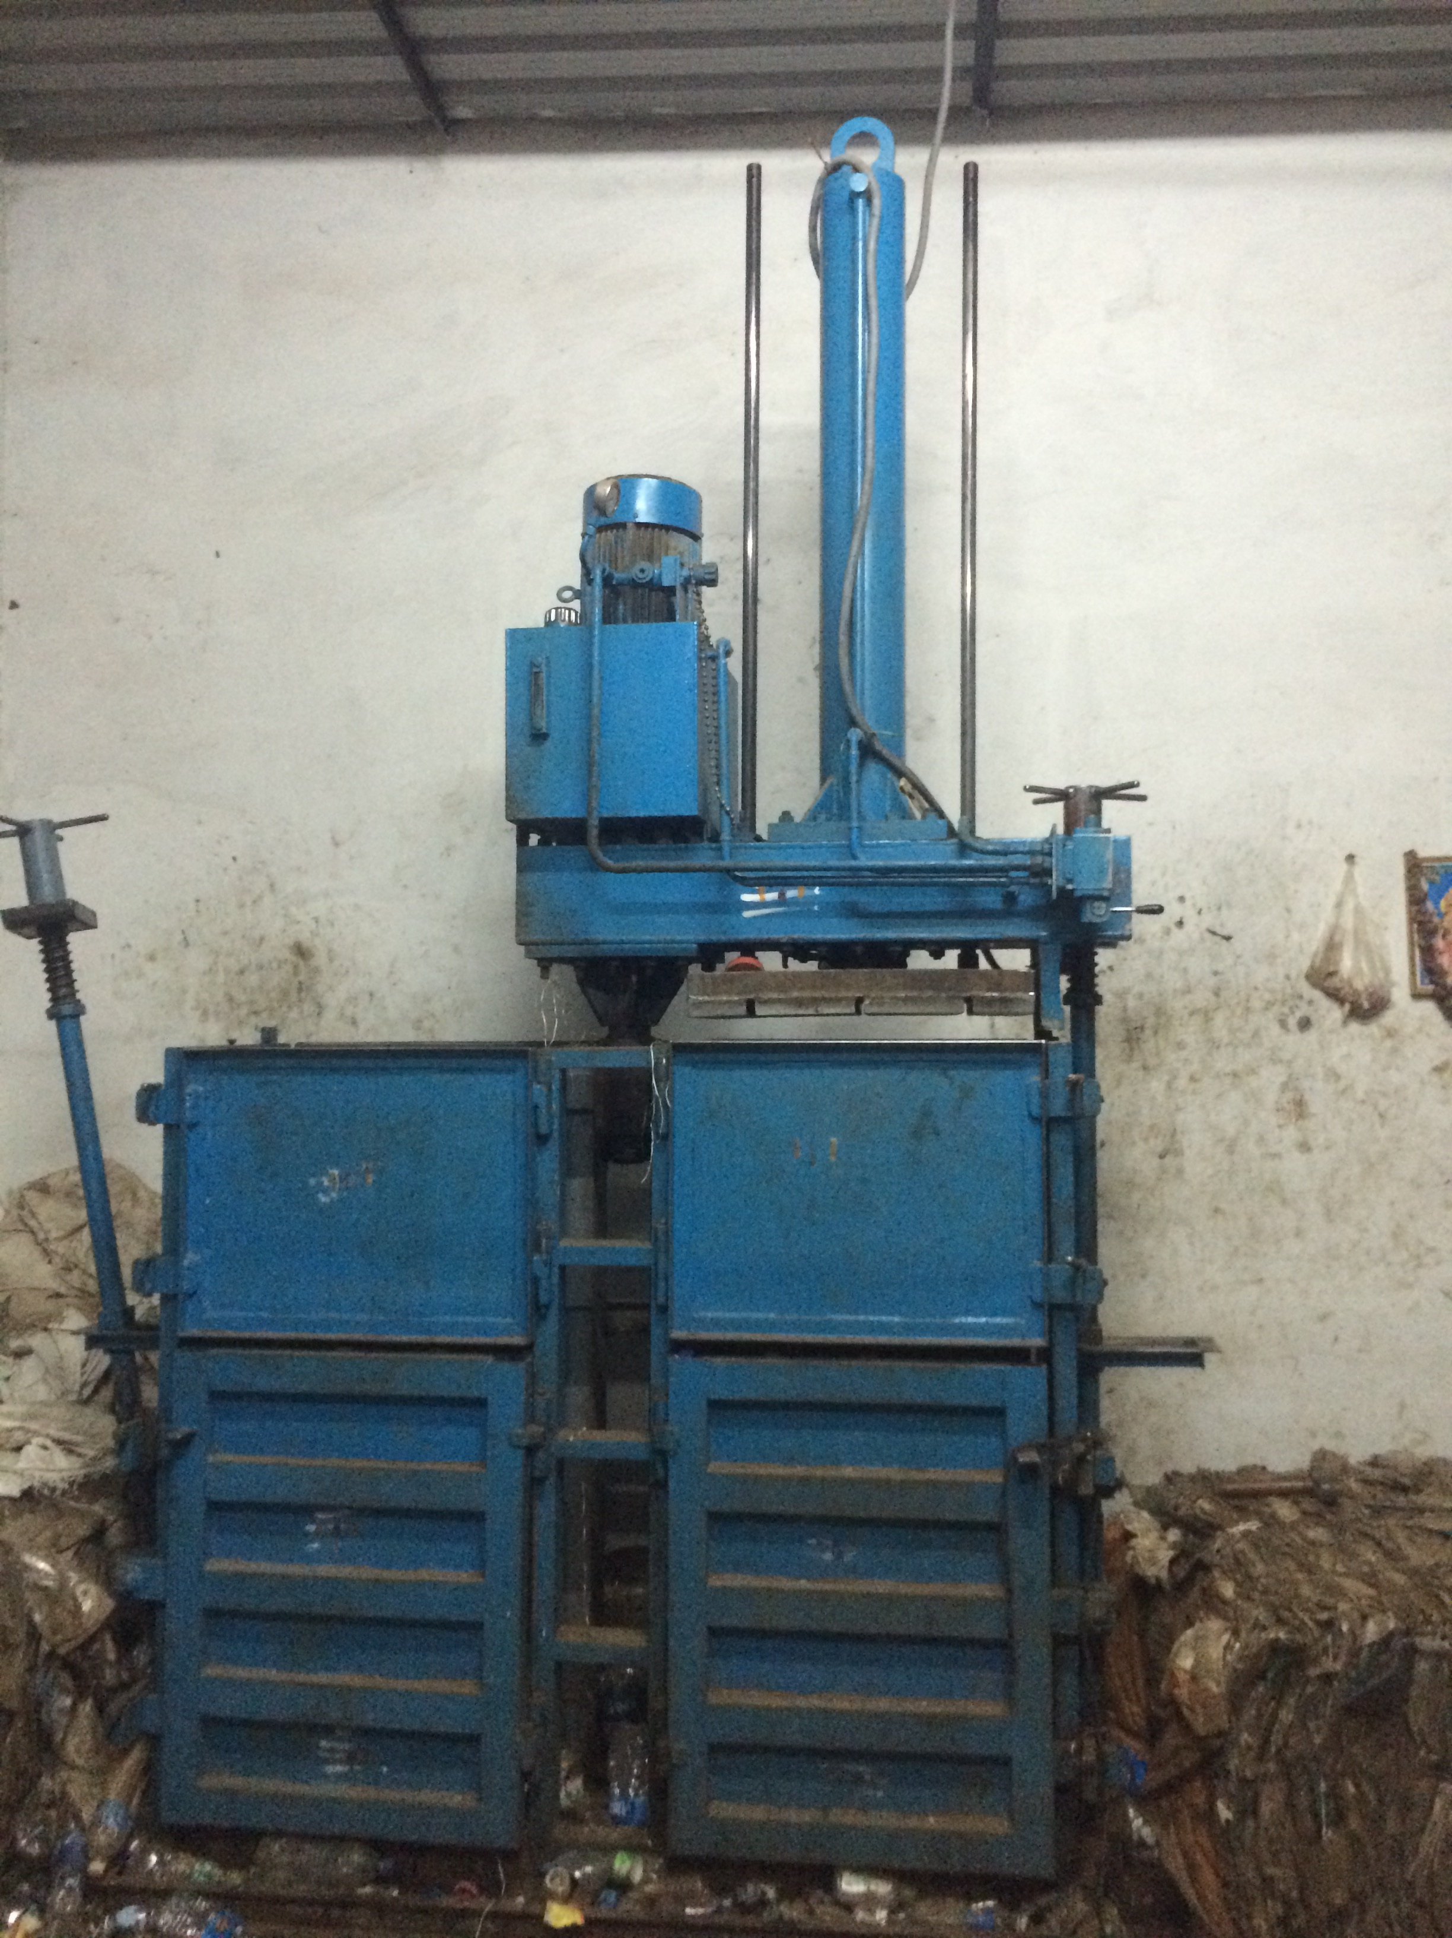

For TECHNO MACHINE TOOLS

( T. SIVARAMAKRISHNA)

